**• What is software? What is software engineering?**

**ANS:-** :- **software:-** software is a thing which we can

touch.

Like- keyboard; mouse; monitor; cpu; etc.

**Software engineering** :- Software engineering is process of analyzing user requirement and then designing, building and testing software application which satisfy that requirements.

It is a branch of engineering that helps to develop and build a software.

**• Explain types of software :-**

**Ans:- There is main 5 types of software**

1.application software

2.system software

3.driver software

4.middleware

5.programming software

**1.Application Software :-** The most common type of software is application software. Application software is a computer software. It can be a group of of programs that run the application for the users.

Eg. Ms office; paint; power paint; graphic software; image editor etc.

**2.system software:-** These software programs are design to run a computer applications programs and hardware. It manages all the computer programs.

Eg. Notepad; calculator; etc.

**3.driver software:-** Driver software is also known as a device driver. Every device that is connected to a computer needs at least one device driver to function.

Like usb storage device.

Eg. Audio drivers; video drivers; etc. it helps to run some video or audio files.

**4.middleware** :- Middleware enables Microsoft windows to talk to excel and word.

Eg. Database middleware; etc.

**5.programming software** :- Computer programmers use programming software to write code.

Eg. Turbo c; esclip; compiler; etc.

**• What is SDLC? Explain each phase of SDLC ?**

**Ans:-** The SDLC (software development life cycle)is the cost-effective and time efficient process that development use to design and build high quality software.

1. **Requirement geathering :-** This is the first and fundamental stage of SDLC. Business analysts gather requirement from their customers to create a business specification document.

1. **Analysis:**- This is the second stage of SDLC. Organization and other team may refer to this document as customer requirement and specification.
2. **Designing:**- This is the third phase of SDLC. The design phase is where you put pen to paper. Creating a pre-production version of the product can give the opportunity to visualize what the product will look like.
3. **Impliment & coading:**- This is the phase four of SDLC. The programming code is built as per the phase 3 (DESINGING). So the product can be created with the utmost efficiency. Developers use various tools and programming languages to build the code.

**Programming tools:-** compilers; interpreters.

**programming languages :-** c; c++ ; java; php; etc**.**

1. **Testing :**- This is the fifth phase of SDLC.Where the development team tests the software for errors and deficiencies. Does the software produce the right result? Does it fulfil the requirements? Etc…….
2. **Deployment:-** In this stage, the software system is deployed to the production environment or released to the customers. This involves installing the software on the end-users' systems and ensuring that it works correctly in the production environment.
3. **Maintenance :**- This is the sixth last phase of SDLC. Each person has different needs, there may be unique issues come up and needs to be addressed. The customer issues are solved in this maintenance phase. Development teams can make any last adjustment prior to its final realese.

**• What is DFD? Create a DFD diagram on Flipkart**

**Ans:-** A data flow diagram (DFD) is a graphical or visual representation using a standardized set of symbols and notations to describe a business's operations through data movement. They are often elements of a formal methodology such as Structured Systems Analysis and design Method.

1. 0 level DFD

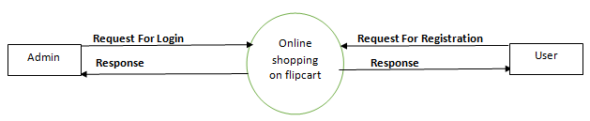

1. **1st level DFD**

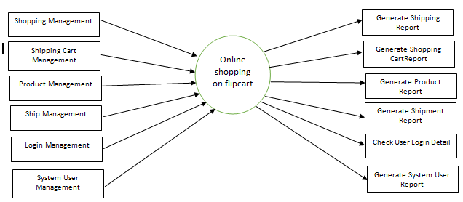

1. **2nd level DFD**

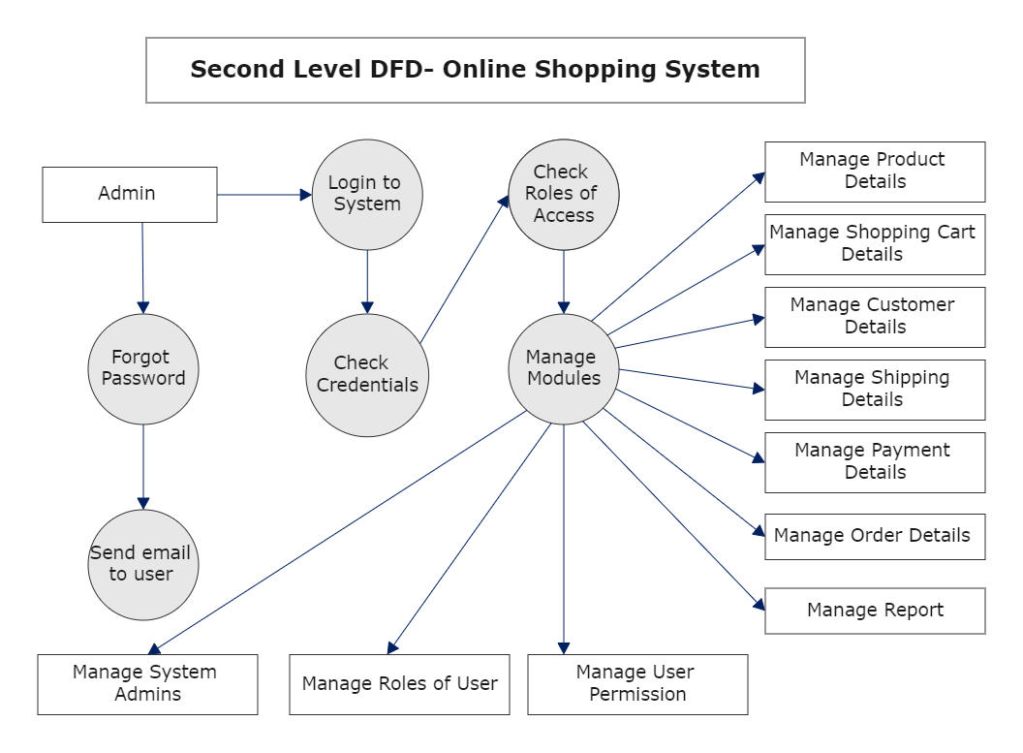

**• What is Flow chart? Create a flowchart to make addition of two numbers**

**Ans:-** A flowchart is a picture of the separate steps of a process in sequential order. It is a generic tool that can be used to describe various processes, such as a manufacturing process, an administrative or service process, or a project plan.

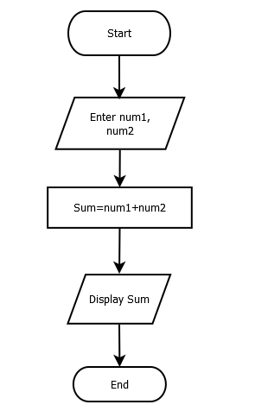

**• What is Use case Diagram? Create a use-case on bill payment on paytm**

**Ans:-** Use-case diagrams describe the high-level functions and scope of a system. These diagrams also identify the interactions between the system and its actors.

The use cases describe the actions or functions that the system performs in response to the user or actor's actions. The relationships between the actors and the use cases are represented as lines or arrows. Use case diagrams are often used to help define the requirements for a system, and to ensure that all the necessary functionality has been included in the system design.

